Impact of a multi-Cancer Early Detection screening programme in England on diagnostic demand - a modelling study: Uptake scenario 70%

Figure 1: Monlthy time series of English diagnostic modality usage from April 2018 to April 2024
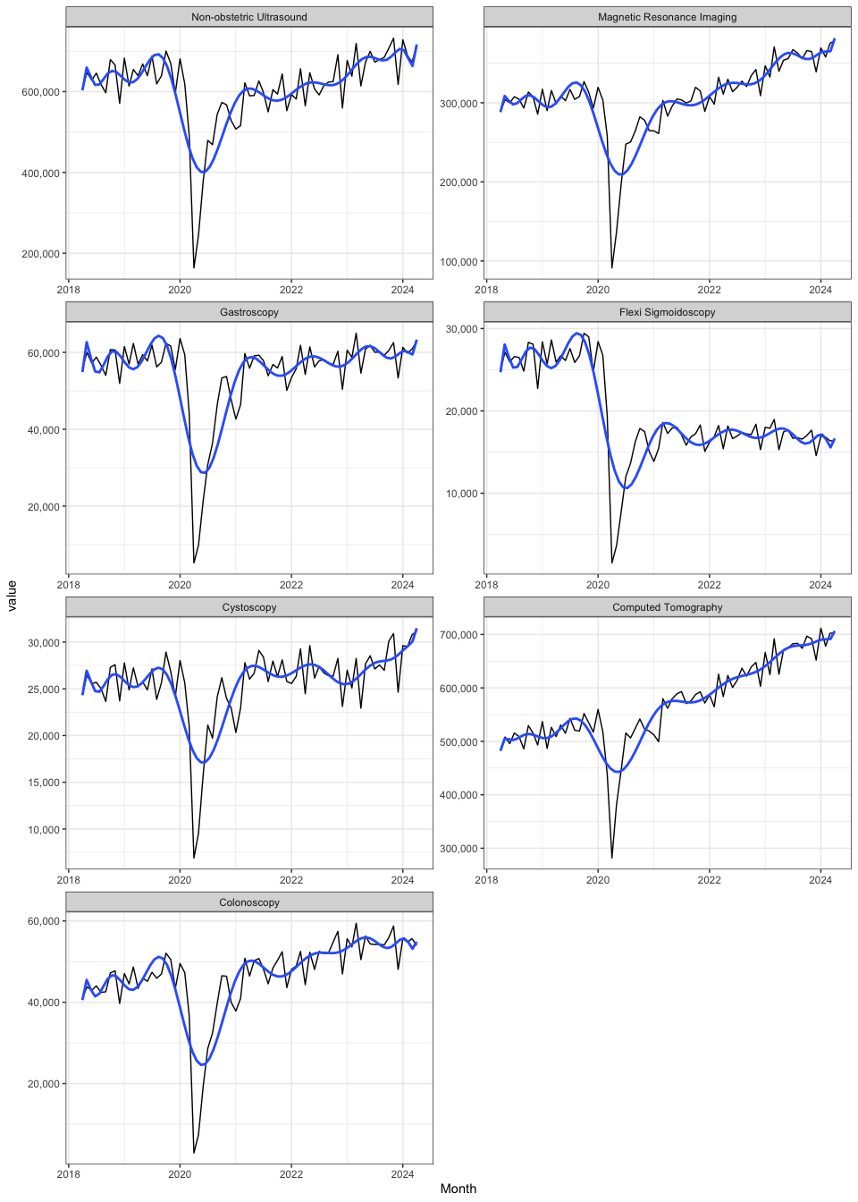

Results table 1: Increase in annual diagnostic modality usage in relation to English total usage for the period May 2023 to Aprial 2024
 |  | Prevalent round |  |  |  |  | Steady state
 |  | MCED screening programme scenario |  |  | Per 1 million screened |  | MCED screening programme scenario |  |  | Per 1 million screened
Diagnostic modality | Total usage in England 2023/24 | Estimated annual use (n) associated with MCED screening | Percentage (%) increase in total annual usage | Percentage increase attributable to true (false) positives | Estimated annual use (n) associated with MCED screening | Percentage (%) increase in total annual usage | Estimated annual use (n) associated with MCED screening | Percentage (%) increase in total annual usage | Percentage increase attributable to true (false) positives | Estimated annual use (n) associated with MCED screening | Percentage (%) increase in total annual usage
Biopsy | NA | 19793.3 | NA | NA (NA) | 1498.6 | NA | 7267.1 | NA | NA (NA) | 550.2 | NA
Colonoscopy | 656072 | 38761.1 | 5.9 | 1.9 (4) | 2934.6 | 0.4 | 12750.4 | 1.9 | 0.6 (1.3) | 965.3 | 0.1
Computed Tomography | 8221580 | 141613.3 | 1.7 | 0.3 (1.4) | 10721.6 | 0.1 | 50487.5 | 0.6 | 0.1 (0.5) | 3822.4 | 0.0
Cystoscopy | 344567 | 3945.9 | 1.1 | 0.4 (0.8) | 298.7 | 0.1 | 1294.8 | 0.4 | 0.1 (0.3) | 98.0 | 0.0
Flexi Sigmoidoscopy | 200863 | 1141.6 | 0.6 | 0.2 (0.4) | 86.4 | 0.0 | 465.6 | 0.2 | 0.1 (0.2) | 35.3 | 0.0
Gastroscopy | 723178 | 25930.0 | 3.6 | 1.1 (2.5) | 1963.2 | 0.3 | 9074.9 | 1.3 | 0.4 (0.9) | 687.1 | 0.1
Magnetic Resonance Imaging | 4346324 | 4978.0 | 0.1 | 0 (0.1) | 376.9 | 0.0 | 2407.7 | 0.1 | 0 (0) | 182.3 | 0.0
Non-obstetric Ultrasound | 8267797 | 37265.9 | 0.5 | 0.1 (0.3) | 2821.4 | 0.0 | 13812.7 | 0.2 | 0.1 (0.1) | 1045.8 | 0.0

Figure 2: Monlthy time series of English diagnostic modality usage from April 2018 to April 2024

